# BMET4790:BIOMECHATRONICS

# TUTORIAL: ECG Analysis

Name: Hunter Tambimuttu SID: 510448271

Name: Caleb Nazareth SID: 530372811

Name: Gabriel Ralph SID: 470205736

Note: Activity needs to be completed and submitted before the start of the next tutorial

THIS TUTORIAL SHOULD TAKE A TOTAL OF 4 HOURS TO COMPLETE

Notes:

* Answer questions briefly and clearly within the blocks provided
* A signed plagiarism coversheet must be included with the submission
* A soft copy (including MATLAB listings) must be submitted through Canvas
* Tutorials submitted after the due date will lose 5% per day (or part thereof) unless accompanied by a valid doctor’s certificate.
* Use this document as a template for your submission

**Tutorial**

Copy the ascii file **ecg_gb.tx**t from the Biomechatronics site on Blackboard

Load the file into the MATLAB workspace using the **LOAD** command

This file consists of the 12 seconds of digitised output from the ECG at a sample rate of 100 samples/sec

**Question 1: Initialisation**

1. Determine the number of data points in the file using SIZE or LENGTH command (show the code snippet that you used) (1)

n = length(ecg_gb);

1. Create a time vector of the correct length with the correct sample interval using the LINSPACE command (show the code snippet) (1)

t = linspace(0, 12, n);

**Question 2: Plotting the Raw Data**

1. Plot the raw voltage data as a function of time using the PLOT command (3)
   * Generate a grid using the **GRID** command (1)
   * Generate axes labels using the **XLABEL** and **YLABEL** commands(1)
   * Generate a title using the **TITLE** command (1)
   * The result should look something like this

*Note that all graphs generated must include these details*



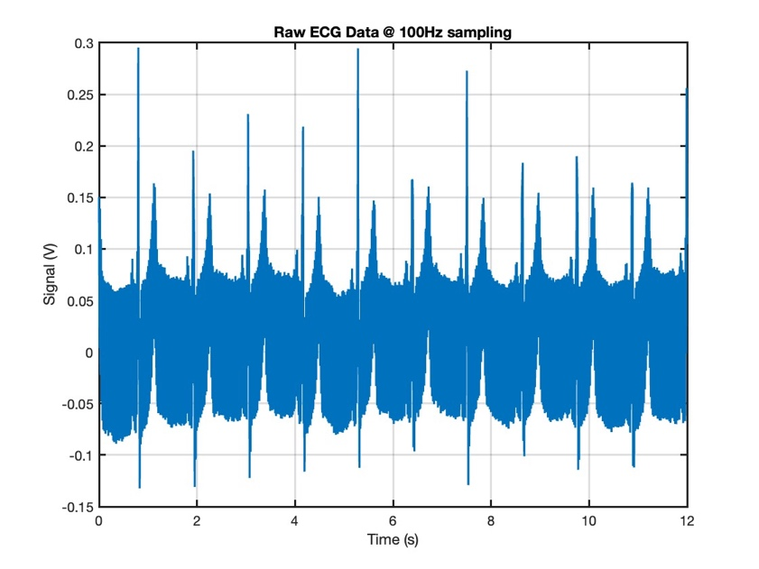

**Question 3: Characterising the Noise**

1. Plot a 0.5s long subset of the voltage data as a function of time (starting at t=0) to see what the noise looks like. (3)

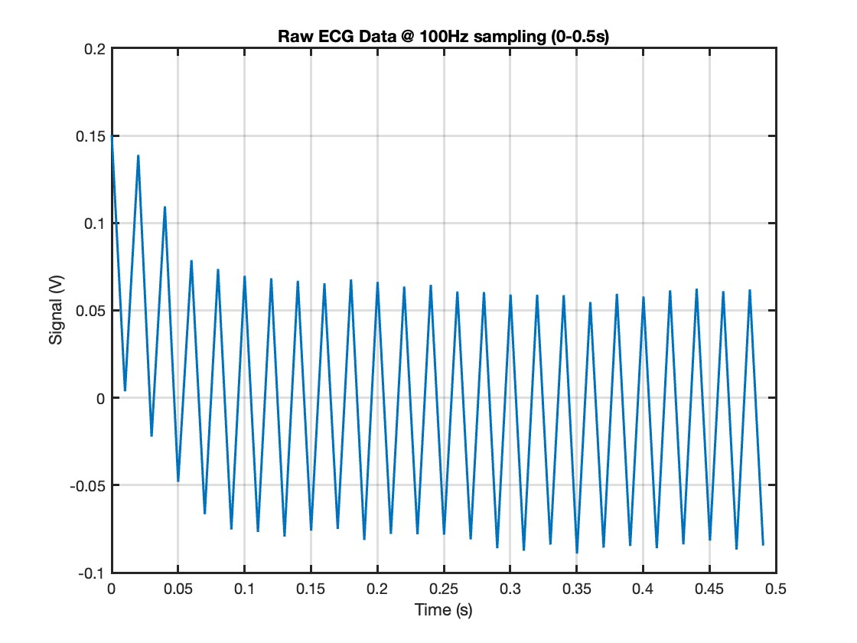

1. Consider the noise from a sampled data perspective and explain why it looks like it does (4)

By looking at the time between peaks, the frequency of the noise is 50 Hz and is fairly consistent. This would mean that it is likely cause by mains hum

1. From the graph determine the fundamental frequency of the noise in Hz (measure the period between noise cycles and take the reciprocal) (2)

Period is 0.02s, therefore frequency is 50 Hz

**Question 4: Filtering out the Noise**

As most of the useful information contained within the ECG signal occurs between DC and 25Hz, it is possible to remove the 50Hz mains noise using a low-pass filter

1. Use the **BUTTER** command to generate the digital filter coefficients [b25,a25] for a 3rd order Butterworth low-pass filter with a cutoff frequency of 25Hz (show the code snippet you used) (2)

Fc = 25;

[b25,a25] = butter(3, Fc/(Fs/2));

1. Compare the coefficients to those shown below, and identify the one that has been deliberately altered (2)

b = 0.1667 0.5000 0.5000 0.1667

a = 1.0000 -0.0000 0.5555 -0.0000

b25 = 0.1667 0.5000 0.5000 0.1667

a25 = 1.0000 -0.0000 0.3333 -0.0000

1. Pass the raw ECG signal, ecg_gb, through the digital filter to produce the filtered output called ecg_fil25 as a function of time. Use the **FILTER** command to do this (show the code snippet you used). (1)

ecg_fil25 = filter(b25, a25, ecg_gb);

1. Plot the resultant signal which, including annotation should look something like this (5)



Plot your version of the graph here

1. Generate new coefficients [b5,a5] for a 3rd order Butterworth filter with a cutoff frequency of 5Hz (2)

b5 = 0.0029 0.0087 0.0087 0.0029

a5 =1.0000 -2.3741 1.9294 -0.5321

1. Pass the original ECG signal, ecg_gb, through the digital filter to produce the filtered output called ecg_fil5
   * Plot and annotate the filtered ecg signal (5)

Graph here

1. Describe the main differences between ecg_fil5 and ecg_fil25 and explain why this occurs (5)

The peak of the P part of the curve is much smaller in the 5 Hz filter and the curve is much smoother than the 25 Hz filter. This is expected as the higher frequencies are attenuated more in the 5 Hz which removes the spike for the P waves and the high frequency noise.

**Question 5: Filter Transfer Function**

1. The transfer function of a filter is best described by plotting the gain as a function of frequency.

* Determine the gain and phase [h25,w25] of the 25Hz cutoff frequency filter using the **FREQZ** command
* The normalised filter gain is equal to the absolute value of h25. This can be plotted as a function of frequency by creating the correct vector describing the frequency axis
* Note that the FREQZ command produces an output for values of frequency between DC and fs/2
* After annotation your result should look something like this (5)



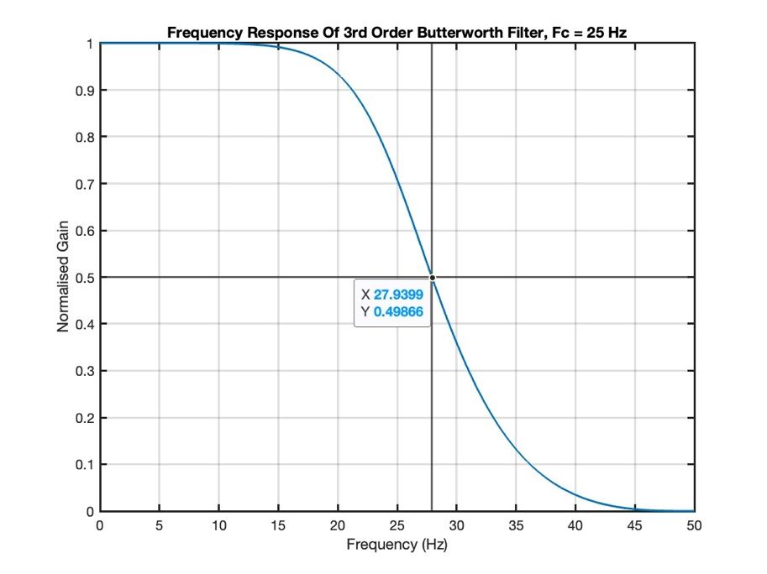

1. The cutoff frequency, fc, is defined as the frequency when the signal power is reduced by half from its nominal value in the pass band. Mark this on your graph and justify its position (4)

Annotation of graph & Justification

1. Generate a new graph for the filter with a 5Hz cutoff frequency and compare the two by plotting on the same axes (4)

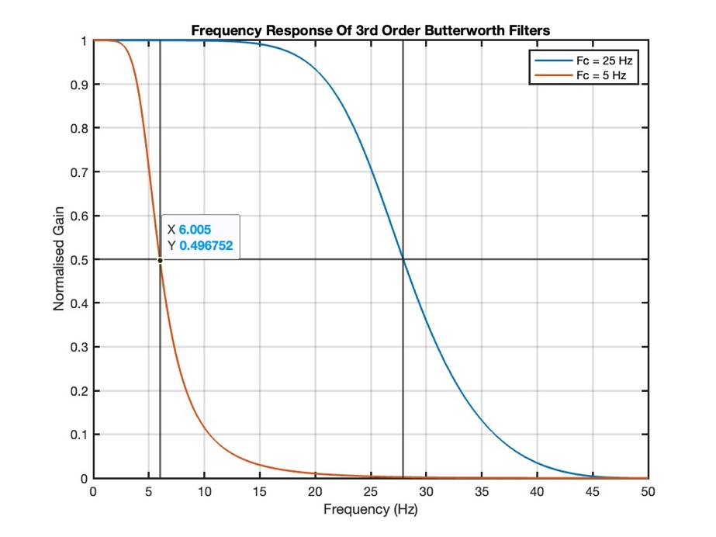

**Question 6: Frequency Content of the Signal**

The frequency content of a signal can easily be obtained using the Fast Fourier Transform (FFT)

1. Generate the complex spectrum using the **FFT** command on the first 1024 points of the signal filtered at 25 Hz, ecg_fil data

* Because of the nature of the FFT, only the first 512 points of the spectrum are valid, they correspond to frequencies from DC to fs/2
* It is convenient to convert the absolute value of the spectrum to a decibel scale before plotting. Use ampdB = 20*log10(abs(amp)) to achieve this
* Generate the frequency axis for the graph over the appropriate span with the correct number of points and plot and annotate the spectrum
* It should look something like this (5)



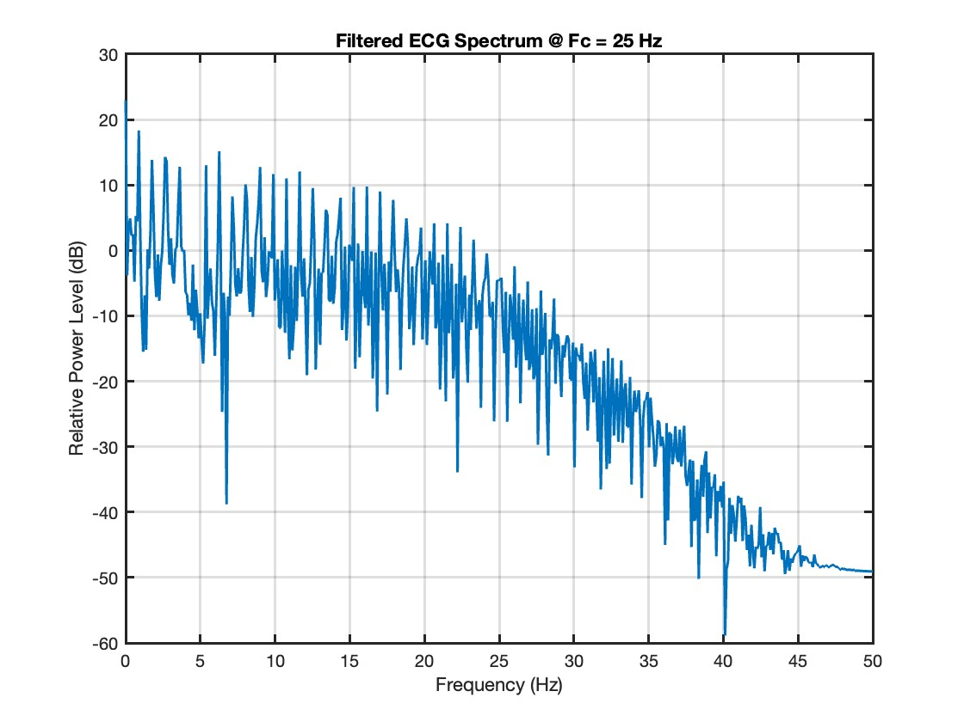

1. Zoom in onto the first peak, plot it and use that to determine the heart rate as accurately as possible (4)

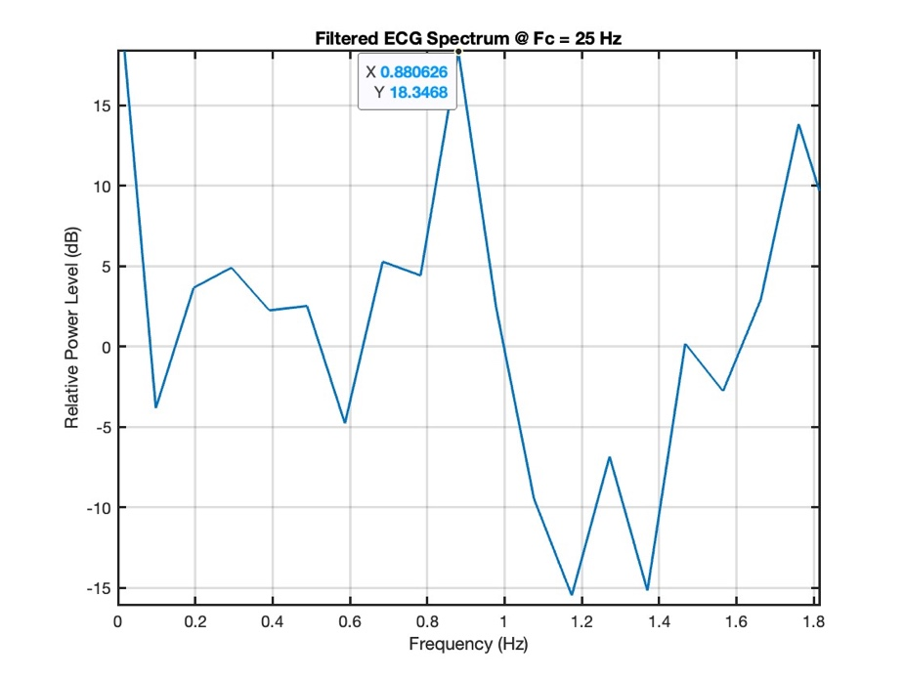

f = 0.880626 Hz

BPM = 60 * 0.880626 = 52.8 bpm

1. Confirm this is correct from the filtered time domain signal plotted earlier. Show your measurement made over 9 cycles on a copy of the figure (3)

T1 = 0.81, t10 = 10.89

Dt = 10.08

F = 9/10.08 = 0.9

BPM = 0.9 * 60 = 54 bpm

Convert this to a rate in beats per minute (2)

Already done

1. Briefly explain the important characteristics of this spectrum
   1. The comb of spikes (2)
   2. The first peak (above DC) (2)

The first peak of the spectrum above DC gives the heart rate which is the most common frequency.

* 1. To understand the general shape of the signal in the frequency domain, extract a single heartbeat cycle and plot it along with the spectrum for that single cycle (10)

* 1. Comment on the shape of the spectrum based on the shape of the individual QRS and T components of the heartbeat (6)

Period of the QRS complex is 0.08*2 = 0.16s which means the frequency is 6.25 Hz which is a spike that can be seen on the spectrum. Doing the same for the T bump, we get a frequency of 2.5 Hz which is again seen as a peak on the spectrum.

* 1. Can you see a similarity between the spectrum of the repeated ECG signal and that of a single heart beat? (2)

After about 15 Hz, the power level of the signal begins to decline steadily on both the ECG and single heartbeat signal.

Total (88)